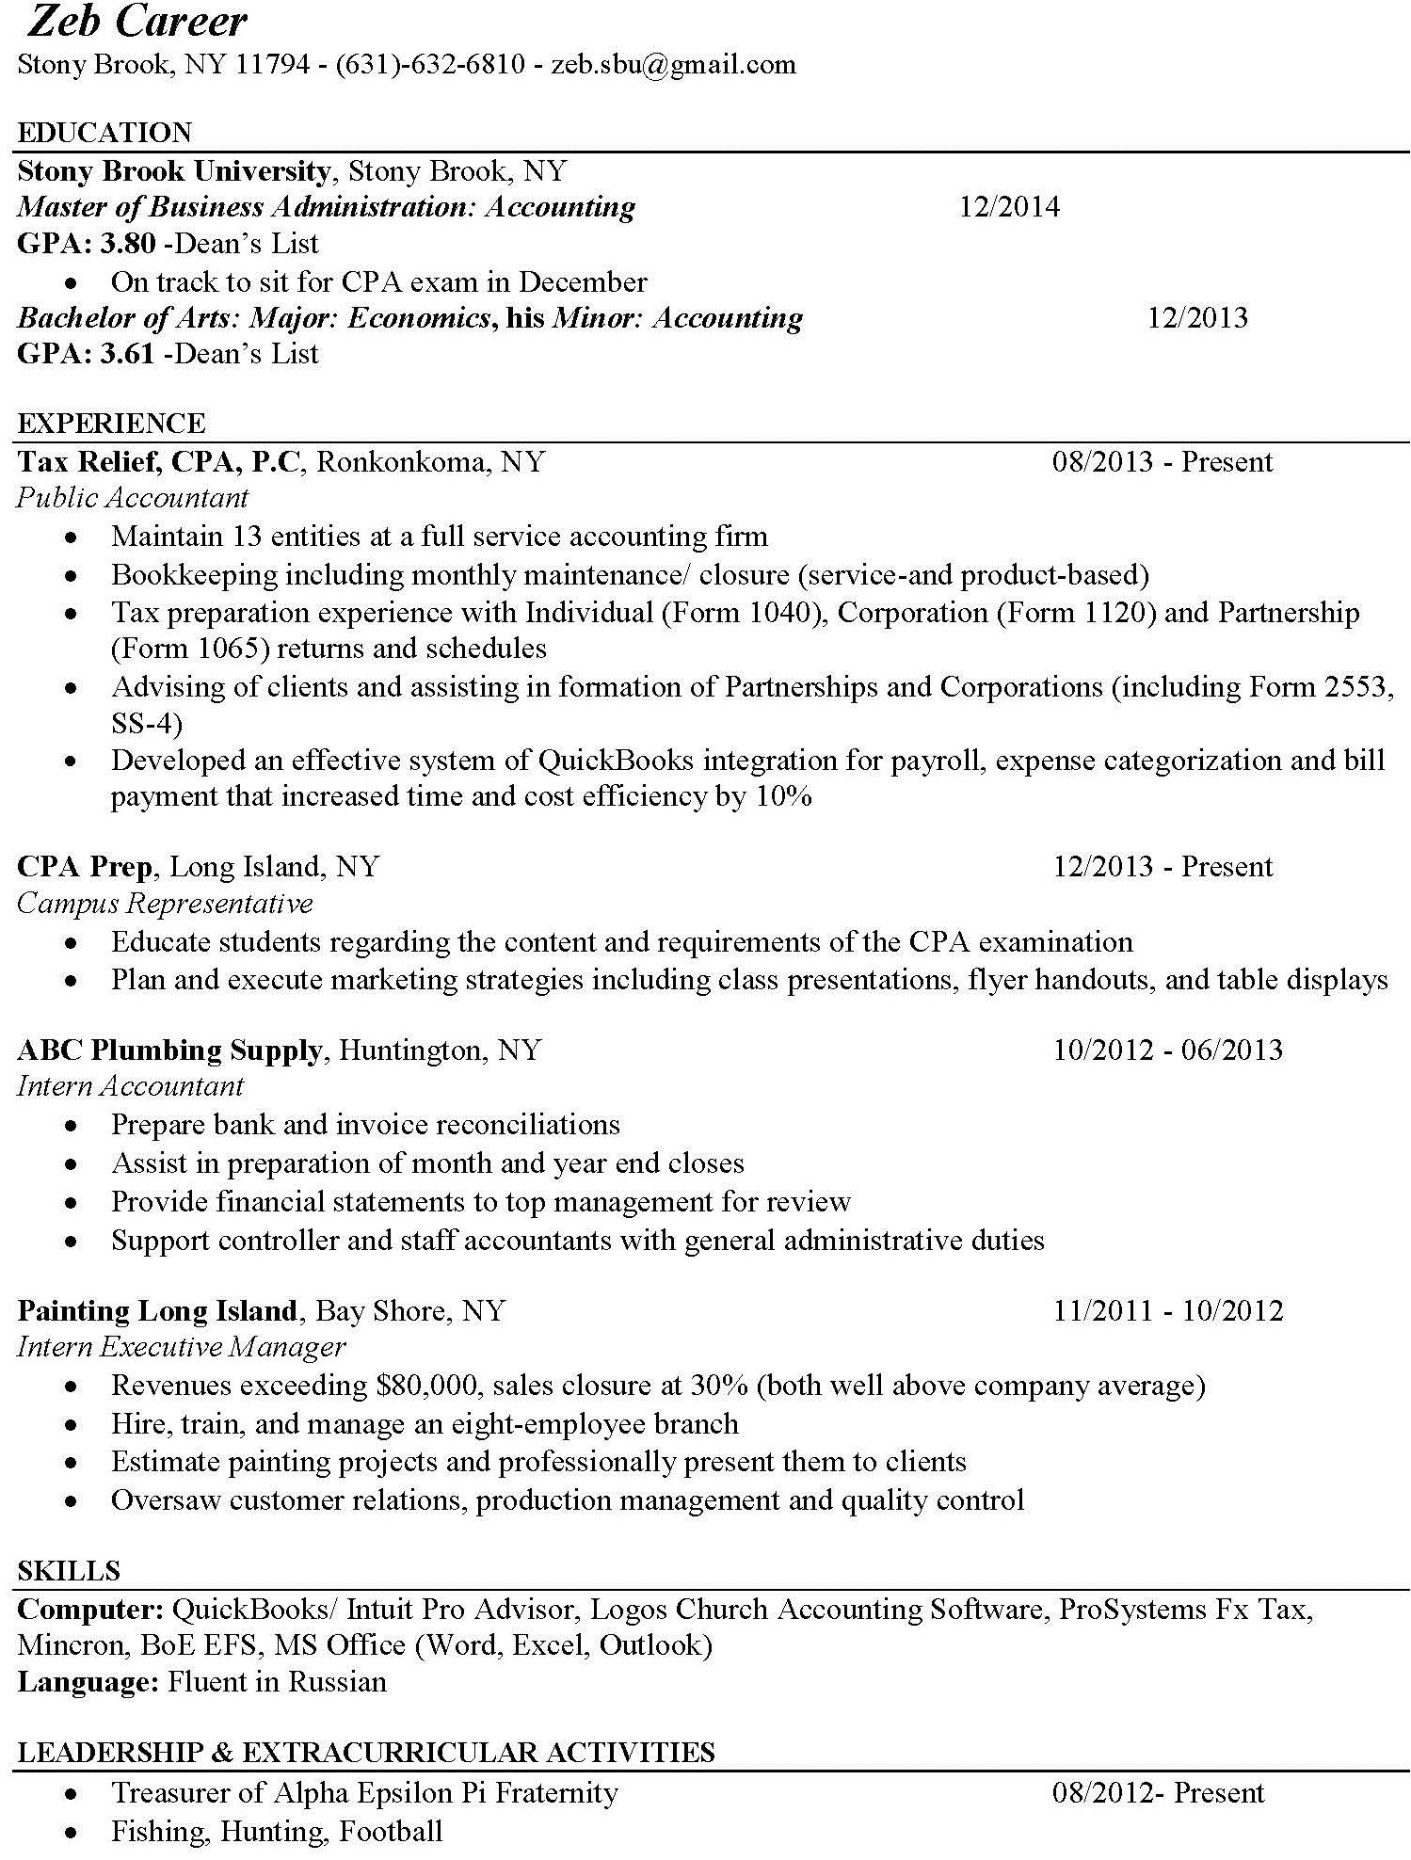MBA in Accounting

Name

City/Town, State, Zip Code - Phone Number - Email Address

