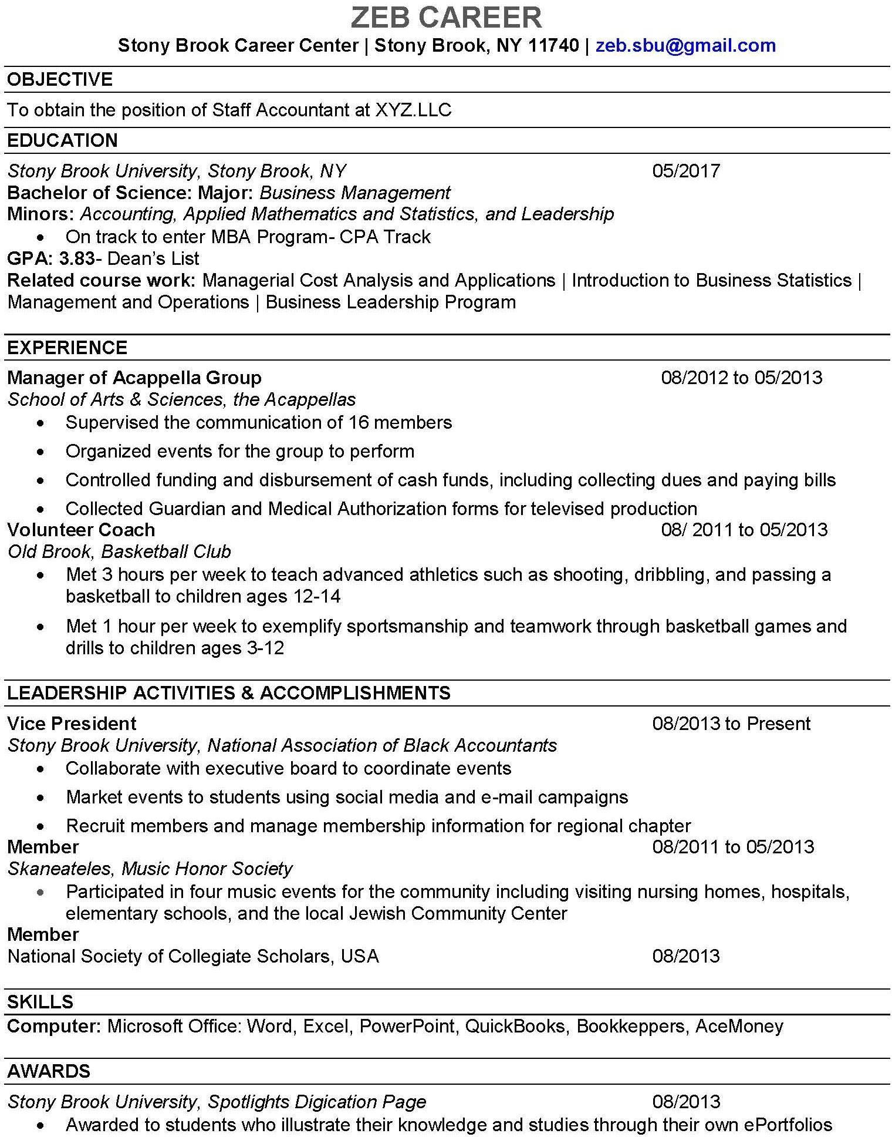Business Management Major / ACC Minor
Name
Address | City/Town, State, Zip Code | Email

