Graphic Design Services – Price List
POSTER SIZES

Logo Design
LOGOS
Logo
Three (3) Initial Logo Concepts
Allowance for no more than 3 modiﬁcations to one design Final artwork supplied in .PDF, .JPG and .PNG ﬁle format

Stationery Design
BUSINESS CARDS
BANNERS
Business Cards
One (1) Initial Business Card Layout
Allowance for no more than 3 modiﬁcations to one design
Final artwork supplied in .PDF format
Letterhead
One (1) Initial Letterhead Design Layout concept Allowance for no more than 3 modiﬁcations to one design Final artwork supplied in .PDF and Word document format Includes colour and B/W versions
With Compliments Slips
One (1) Initial With Comp Slips Design Layout
Allowance for no more than 3 modiﬁcations to one design Final artwork supplied in .PDF and Word document format Includes colour and B/W versions
Envelopes
One (1) Initial Envelope Design Layout
Allowance for no more than 3 modiﬁcations to one design
Final artwork supplied in .PDF format
Presentation folders
One (1) Initial Presentation Folder Layout
Allowance for no more than 3 modiﬁcations to one design
Final artwork supplied in .PDF format
Notepads
One (1) Initial Notepad Layout
Allowance for no more than 3 modiﬁcations to one design
Final artwork supplied in .PDF format
Award Ceremony Covers
One (1) Initial Cover Layout
Allowance for no more than 3 modiﬁcations to one design
Final artwork supplied in .PDF format
Certiﬁcates
One (1) Initial Cover Layout
Allowance for no more than 3 modiﬁcations to one design
Final artwork supplied in .PDF format

Posters and Banner Design
 | A4 | A2
A5
A3
A1

Banners
Any size ﬂat banner design
One (1) Initial Poster or Banner Design Layout
Allowance for no more than 3 modiﬁcations to one design
Final artwork supplied in .PDF format
Posters - Individual
Any size Poster design*
One (1) Initial Poster or Banner Design Layout
Allowance for no more than 3 modiﬁcations to one design
Final artwork supplied in .PDF and .JPG format
Posters - Series
Any size Poster design series*
3 or more related with similar styling
One (1) Initial Poster or Banner Design Layout
Allowance for no more than 3 modiﬁcations to one design
Final artwork supplied in .PDF and .JPG format
*A5 - A1 size only

Existing Design Alterations
Print
Modiﬁcations or alterations to existing artwork

Web and Social Media Design
EMAIL SIGNATURES

Email Signatures
One (1) Initial Email Signature Layout
Allowance for no more than 3 modiﬁcations to one design
Final artwork supplied as .PNG Installation help provided if required
Email Template – Newsletter
One (1) Initial Email Template Newsletter Layout concept Allowance for no more than 3 modiﬁcations to one design Final artwork supplied as .PNG
Installation help provided if required
Email Template – General
One (1) Initial Email Template General Layout concept Allowance for no more than 3 modiﬁcations to one design Final artwork supplied as .PNG
Installation help provided if required
PowerPoint Template (Any Dimensions)
One (1) Initial PowerPoint Layout concept
Allowance for no more than 3 modiﬁcations to one design
Final artwork supplied .PPT Installation help provided if required
Facebook Page
One (1) Initial Facebook page concept Final artwork supplied as .PNG Installation help provided if required
Website
One (1) Initial Website Layout concept
Allowance for no more than 3 modiﬁcations to one design
Final artwork supplied as .PNG and fully installed
Copywriting of website content
Full website copy delivered for copywriting, editing and
proofreading supplied as Word document Installation help provided if required

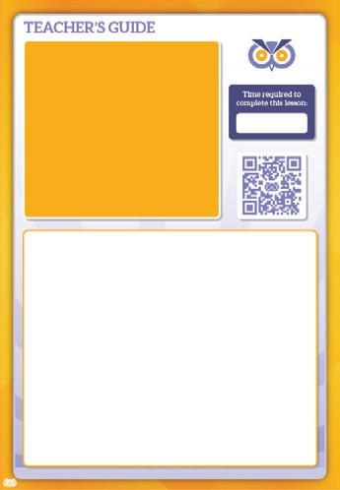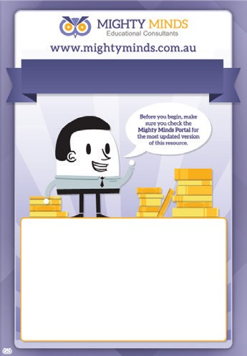Brochure Design
BROCHURES
POWERPOINT TEMPLATES
A4 Brochure Flat (No fold, 2-Fold, 3-Fold)
210mm x 297mm
One (1) Initial A4 Brochure Design Layout
Allowance for no more than 3 modiﬁcations to one design
Final artwork supplied in .PDF format
A4 Brochure Booklet
One (1) Initial A4 Brochure Design Layout
– multiples of 4 pages
Allowance for no more than 3 modiﬁcations to one design
Final artwork supplied in .PDF
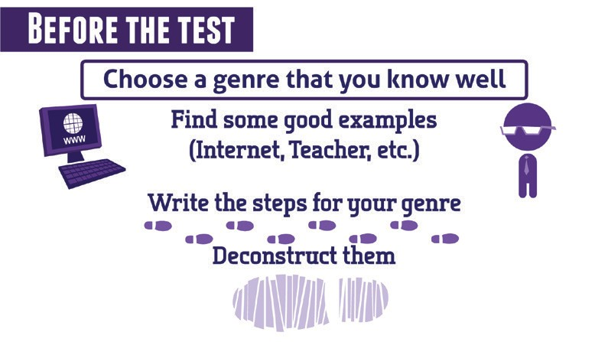Multimedia and Animation
VIDEOS
Video (up to one minute)
One (1) Initial Video Concept
Allowance for no more than 3 modiﬁcations to one design
Final video supplied in .MP4, .MOV or .AVI format
Video (more than one minute)
One (1) Initial Video Concept
Allowance for no more than 3 modiﬁcations to one design Final video supplied in .MP4, .MOV or .AVI format Installation help provided if required
*Pricing is a guide. A ﬁnal quote will be supplied after the scope of the project has ben submitted.

Other Designs
Style Guide
Detailed style guide to ensure brand consistency
Provided as a .PDF
Staﬀ Badge
One (1) Initial Badge Concept
Allowance for no more than 3 modiﬁcations to one design Final artwork supplied in .PDF, .JPG, .PNG and .EPS ﬁle format

