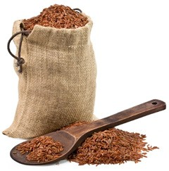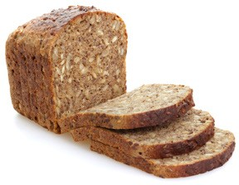Healthy Grocery List Items

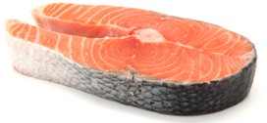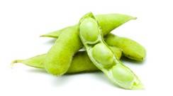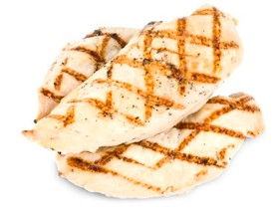

*Always have:*

* Boneless, skinless chicken breast
* Wild salmon
* Filet, hanger, flank, sirloin, or 93% lean ground beef

*(Ideally grass-fed and organic)*

* Turkey bacon

*Vegetarians and vegans, always have:*

* Firm tofu
* Tempeh
* Frozen edamame

**MEAT/PROTEIN**

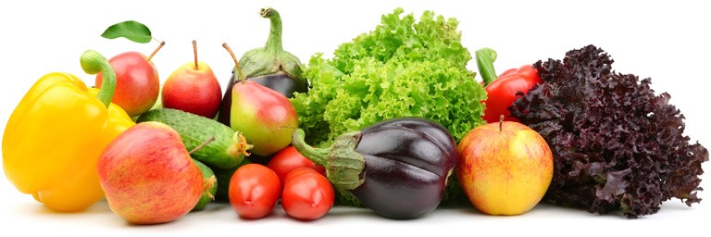

*Always have:*

* Onions
* 3 in-season fruits*, including 1 berry
* 5 in-season vegetables*, including 1 leafy green

*\*Aim for one new fruit and one new vegetable (or ones you haven’t had in a while)*

**PRODUCE**

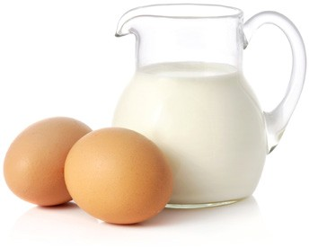

*Always have:*

* Nonfat milk or non-dairy milk
* Low-fat or nonfat plain Greek or regular yogurt
* Eggs

*Optional:*

* Parmesan cheese
* Low-fat cheese

**DAIRY**

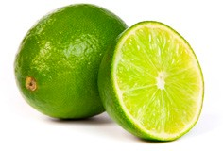

*Always have:*

* Kosher salt
* Black pepper
* Lemons or limes
* Fresh or bottled minced garlic
* Agave

*Optional:*

* Sea salt
* Fine salt
* Capers

**SEASONINGS**

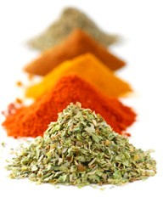

*Always have at least two of your favorites, such as:*

* Cinnamon
* Cumin
* Crushed red pepper
* Rosemary
* Thyme
* Tumeric

**DRIED HERBS & SPICES**

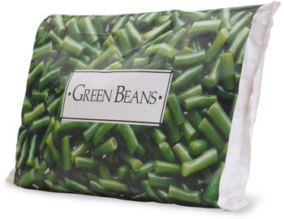

*Always have at least one of each of the following:*

* Vegetables
* No-sugar-added berries or other fruit

*Always have one of the following:*

* Extra-lean ground turkey meat
* Vacuum-sealed fish
* Shrimp

*Always have at least one of the following:*

* Vegetable burgers

*(no more than 200 calories, at least 4g protein and 4g fiber; be sure vegetables are in the ingredients list)*

* Healthy meals

*(with no more than 500mg sodium per serving)*

**FROZEN FOODS**

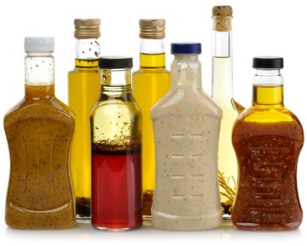

*Always have:*

* Extra-virgin olive oil
* White wine vinegar
* Mustard
* Low-sodium soy sauce

*Optional:*

* Canola oil
* Other vinegars (balsamic, rice, red wine)
* Ketchup
* Horseradish
* Low-sodium Worcestershire sauce

**OILS, VINEGARS, & CONDIMENTS**

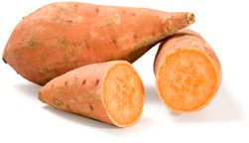

*Always have:*

* High-fiber cereal
* Oats
* Panko breadcrumbs
* Sweet potatoes or yams

*Always have at least one of the following:*

* Whole-wheat or gluten-free pasta
* Brown rice
* Quinoa

*Always have at least one of the following:*

* Whole-wheat, gluten-free, or sprouted bread
* Whole-wheat wraps
* Whole-wheat English muffins

**GRAINS, LEGUMES, & STARCHES**

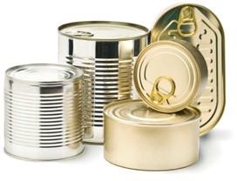

*Always have:*

* Tomato sauce
* Low-sodium vegetable and/or chicken broth
* 1 can no-salt-added beans or lentils
* 1 can chunk light or Albacore tuna
* Low-sodium soup

*Optional:*

* Canned sardines with bones

**CANNED GOODS**

