FIREARM BILL OF SALE

Date of Sale: 03/22/2022

- BUYER

Name: Joel R. Church (hereinafter the “Buyer”)
Address: 4358 Alpine Ave., Monroe, WA 98272
Phone #: (360) 805-5383
Email: joelrchurch@gmail.com

- SELLER

Name: Anna J. Hartman (hereinafter the “Seller”)
Address: 42 Wagner Rd., Monroe, WA 98272
Phone #: (360) 244-0587
Email: annajhartman12@gmail.com

- FIREARM INFO

Make: Smith & Wesson Model: Model 686
Type: ☒ Revolver | ☐ Pistol | ☐ Shotgun | ☐ Rifle | ☐ Other: ____________________________
Caliber/Gauge: 357 Magnum Serial Number (SN): FT5YIYFD09

- PAYMENT (Check one)

☒ PAYMENT. The Buyer agrees to pay the Seller the following in exchange for the Firearm:
Purchase price: $ 850.00 (Taxes included? ☐ Yes | ☒ No)
Paid for via the following payment method: (check one)
☐ Cash | ☒ Check | ☐ Credit / Debit Card | ☐ Other: ___________________________
☐ - GIFT. The Buyer was gifted the Firearm by the Seller.
☐ - TRADE. The Seller traded the Firearm with the Buyer to receive the following Firearm in
exchange: ____________________________________________________________________.

- SELLER’S DISCLOSURE

By signing, the Seller confirms the following:

- All details of the Firearm are correct;
- The Firearm’s serial number is legible;
- The Seller is the lawful owner of the Firearm;
- The right to sell the Firearm is held by the Seller;
- There are no known defects associated with the Firearm;
- The Firearm is in fit condition to be used for its intended purpose(s);
- Neither the Seller or Firearm have been used in a manner of questionable or certain illegality; and
- The Seller assumes no responsibility after the transfer of ownership has taken place.

- BUYER’S DISCLOSURE

By signing, the Buyer confirms the following:

- Is not under the legal age to own a firearm;
- Not being convicted of and never been convicted in any court of a crime punishable by imprisonment for a term exceeding one (1) year;
- Not a fugitive and has no outstanding warrants;
- Not an unlawful user of or addicted to any controlled substance;
- Has never been adjudicated as a mental defective or has been committed to a mental institution;
- Not an alien illegally or unlawfully in the United States or an alien admitted to the United States under a nonimmigrant visa;
- Has not been discharged from the Armed Forces under dishonorable conditions;
- Is a citizen of the United States;
- Is not subject to a court order that retrains the person from owning a Firearm;
- Has not been convicted of a misdemeanor crime of domestic violence; and
- Is not a person prohibited under State of Federal law from purchasing a Firearm.

- ADDITIONAL TERMS (OPTIONAL)

___________________________________________________________________________________________________________________________________________________________________________________________________________________________________________________.

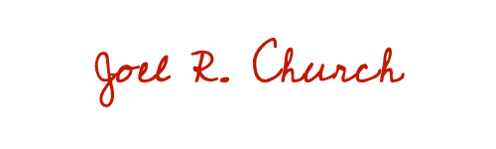
- SIGNATURES

Buyer Signature: _____________________________________ Date: 03/22/2022

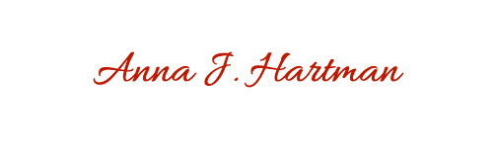
Buyer Printed Name: Joel R. Church

Seller Signature: _____________________________________ Date: 03/22/2022

Seller Printed Name: Anna J. Hartman

CERTIFICATE OF ACKNOWLEDGEMENT
(The section below is to be completed by a Notary Public ONLY.)

STATE OF _____________________
COUNTY OF ___________________
On this ______ day of ____________________, 20____, before me _______________________________ (Name of Notary), personally appeared _______________________________ (Seller) and _______________________________ (Buyer), who proved to me through government issued photo identification to be the above-named person(s), in my presence executed the foregoing instrument and acknowledged that he/she/they executed the same as his/her/their free act and deed.

___________________________________________
Notary Public Signature
My commission expires: ______________________

